**ESCUELA SUPERIOR POLITÉCNICA DEL LITORAL**

**FACULTY OF ELECTRICAL AND COMPUTER ENGINEERING**

**SOFTWARE ENGINEERING II**

**STRUCTURAL TESTING WORKSHOP - I TERM 2021**

**Specific Objectives**

1. Specify a set of test cases to ensure the right operation of a software system.

**Student Outcome**

1. Apply computer science theory and software development fundamentals to produce computing-based solutions.

**Section A**

Function bres shown below implements a Bresenham line drawing algorithm.

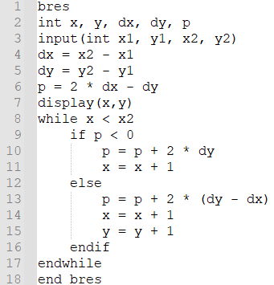

* 1. Draw the data flow graph (DFG) for the bres function.
  2. Give the definition of the du-pair. Identify all the du-pairs for variables “x1”, “x2” and “y” in the bres function and specify their use (p- or c-).
  3. To achieve 100% All-definitions data flow coverage at least one sub-path from each variable definition to some use of that definition (either c- or p- use) must be executed. Using this definition, specify the test cases for variable p.

**Section B**

Program BestInterest in figure below computes balance on an account.

* 1. Draw the Control Flow Graph (CFG) for the BestInterest program.
  2. Annotate the graph showing the basic node types that occur in it.
  3. Give a definition of the DD-path. Draw the DD-path graph for the CFG of the BestInterest program.
  4. Estimate the maximum number of tests necessary for the 100% Path Coverage of the BestInterest program. Explain how you have arrived at this number.
  5. Specify the test cases which ensure the 100% Statement Coverage of the BestInterest program. Explain what is meant by the Statement Coverage. Explain in detail what principles you have used to generate your test cases. Use a simple form of test case specification, i.e., a table with the following headings:

|  |  |  |
| --- | --- | --- |
| Test caseID | Input values | Expected result |

